Ein Bild, das Text enthält.

Some comments on the final report:

(1) If too many people are working in this word, please create your part in a **separate document and then transfer it to the main document**. Otherwise the document will break down.

(2) Please insert the **sources with a footer (Fusszeile)**. We will then merge all sources at the end.

(3) Please **do not change the formatting** anymore.

**Design of Biopharmaceutical Production Facilities**

By group 3:

Genilloud Franck, Khan Salman, Kölbener Christa,   
Kreuzer Jan, Kuleta Natalia Karolina, Lopez Sosa Alejandra,   
Memeti Nurdzane, Müller Benjamin-Anita, Näf Adrian, Nedic Maja,   
Nicollier Alexandre, Noël Jérémie, Pantelidis Alexandros,   
Pesen Pelin, Polini Elisa, Schürch Stefanie,   
Späne Philipp, Xaaji Yusuf, Zuković Dženneta

Master of Life Sciences

BP3

Date of Submission: 18.02.2022

Supervisors:

**Prof. Dr. Dieter Eibl**

**Lukas Hugentobler**

**Sven Kiesewetter**

**M. Sc. Fruhar Mozaffari**

Grüentalstrasse 14, 8820 Wädenswil

Abstract

List of Abbreviations

|  |  |
| --- | --- |
| **Abbreviation** | **Meaning** |
| API | Active pharmaceutical ingredient |
| BDS | Bulk drug substance |
| BP | Buffer preparation |
| BSL | Bio safety level |
| cGMP | Current manufacturing practice |
| CHO | Chinese hamster ovary |
| CNC | Controlled not classified |
| DCS | Distribution control |
| DS | Drug substance |
| DSP | Downstream process |
| HVAC | Heating, Ventilation, and Air conditioning |
| mAb | Mono clinical antibody |
| MP | Media preparation |
| PCS | Process control safety |
| PW | Purified water |
| QC | Quality control |
| SAP | Systems, application & products in data processing |
| SCADA | Supervisory control and data acquisition |
| SUS | Single-use system |
| SUT | Single-use technology |
| URS | User requirement specification |
| USP | Upstream process |
| WFI | Water for injection |
|  |  |

Table of contents

Abstract 2

List of Abbreviations 3

Table of contents 4

1 Introduction 1

1.1 Single-use technology (SUT) 1

1.2 Application of Single-use technology 1

1.3 Group 3 organisation 1

2 Project Management 3

2.1 Occupancy list 3

2.2 Block flow diagram 1

2.3 Area schedule 7

2.4 Zone Concept 7

2.5 Height Concept 7

2.6 Room List and Area Schedule 8

2.7 Staff requirement 9

3 Upstream Process 11

3.1 Introduction 11

3.2 Calculations 11

3.3 Plant on a page 12

3.4 HakoBio room concept 13

3.5 Size and functions of USP system 14

4 Downstream Process 21

4.1 Introduction 21

4.2 Plant on a page 21

4.3 Hako Bio room concept 22

4.4 Size and functions of DSP system 23

5 Media and Buffer preparation 28

5.1 Buffer estimation per batch 28

5.2 Plant on a page 28

5.3 HakoBio room concept of media and buffer preparation 28

5.4 Size and function of MP and BP systems 28

6 Quality Control 29

6.1 Size and functions of QC systems 29

7 Clean facility utilities 30

7.1 List of necessary clean facility utilities 30

7.2 General facility utilities 30

7.3 HVAC 30

7.4 Clean utilities 30

7.5 WFI and clean steam 30

7.6 Technical utilities 30

7.7 Waste 30

8 References 31

List of Images 32

List of tables 33

Appendix I

# Introduction

This report describes the conceptual design (made by a bunch of no idea students) of a biopharmaceutical production facility based on a Chinese hamster ovary (CHO) cell-derived monoclonal antibody (mAb) manufacture. The report follows the user requirement specifications (URS) which is explained in detail in appendix. The case study center on a biopharmaceutical facility that will allow the production of four different mAbs and describes the planning of the entire production process, including upstream processing (USP) and down-stream processing (DSP). The facility tends to employs single-use systems (SUS) and technology (SUT) and theirs allows for a better process by decreased contamination risk in a cheaper and more versatile process.

## Single-use technology (SUT)

As the name suggests, single use technology deals with the use of materials that are disposed of after single use. SUT offers several advantages for a process and is being implemented in various areas of biologics and therapeutic vaccine production.

The usage of presterilized, gamma-irradiated equipment eliminates the need for a clean-in-place(CIP) and a steam-in-place(SIP) operations on the production container. This prevents downtime trough fast replacement of the, as well as energy and solvent consumption. The cost of producing pure steam for SIP process can be avoided, which leads to a significant cost reduction in a faciltiy. It also minimizes the risk of cross-contamination between different products making it a good fit for facilities designed to produce multiple products. Additionally, a cleaning validation is not required, also reducing work effort for the quality control(QC) department of a production site.

Besides the many advantages SUT has to offer, there are also some major disadvantages hindering the use of SU-systems in production processes. One of the major disadvantages are extractables and leachables (E&L), for example the release of parts of the plastic materials of a SU-system, which could get into the product, affecting its overall quality and safety. E&L events can occur under certain conditions, which is why the materials for a particular process should be carefully chosen, with the to-be process conditions in mind. (Pollard, 2018). E&L substances must be minimized as good as possible, as total unavailability of E&L in products are inevitable. E&L substances could have toxic effects dependent on the substances toxicity and there dose inside a batch.Another disadvantage would be the material limitations, as there is no SU-bioreactor available with a volume over 6000L. This section still favours stainless steel bioreactors. Furthermore, the usage of the SU-equipment is restricted to one usage, which than the equipment will be disposed afterwards. Performing a production process with multiple SU-bioreactors trough out the year accumulates a large amount of plastic waste.

Table 1: Advantages and disadvantages of single-use technology (SUT) in production processes of biologics and other pharmaceutical products.

|  |  |
| --- | --- |
| **Advantages** | **Disadvantages** |
| * No CIP- and SIP process needed * Lower labour and utility expanses * Lowering the risk of cross contamination * Quality control on the equipment goes to the provider of the SU-technology | * Release of E&L into the product * Up-scaling is limited trough material limitations * Higher waste production * Staff needed with SUT handling skills * Harder to automate the process |

## Application of Single-use technology

As already mentioned, SUT finds its purpose in areas of efficient and sterile manufacturing processes, such as the production of antibodies against certain diseases or for medication for cancer treatments. The easily replaceable bioreactors reduce time and manpower for the preparation or rehabilitation of a production line, as well as the control of cleanliness.

## Group 3 organisation

The group number 3 will be supervised by Fruhar Mozaffari. Subgroups were built to tackle the different task given, during the project. The assignment of the members to the different groups were conducted by the project management team. Besides the project management team, the additional subgroups were USP, DSP, media preparation (MP), as well as clean utilities and logistics. The whole organigram is illustrated in figure … . Each participant’s name is written to their respect subgroups as well as their affiliated school.

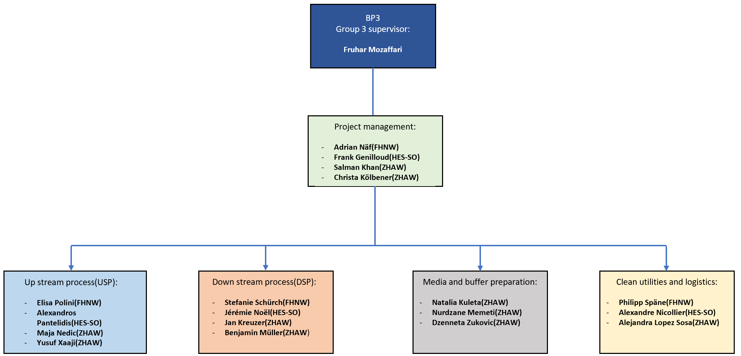

Figure 1: Organigram of group 3. The member of each subgroup are inside of each subgroup fields and their affiliated schools, from the MSLS-alliance, are written next to the respective names. The group supervisor is Fruhar Mozaffari.

# Project Management

This chapter focuses on aspects of production facility planning that fall within the scope of project management tasks.

## Occupancy list

To create a occupancy list fort the production facility, calculation must be made for the products and the amount of batches to be produced to reach a certain target. In this case, the target would be the production of four different mAbs (labled as A,B,C and D). All of the products will be produced by the same CHO platform; thus, the same medium will be used. The amount of product (kg/year), titer (g/L) and yield (g/g) are specified by the URS and is listed in the table … . The calculation of the required batch amounts was summarized and has shown that 72 batches are required to fulfil the requirements of the URS. Part of these calculation will be used to create an occupancy list. More details and the used formula is found in chapter … .

Table 2: Requirements from the URS and calculations for the needed batches, for the four products(A to D).

|  |  |  |  |  |  |  |
| --- | --- | --- | --- | --- | --- | --- |
|  | **Amount [kg/year]** | **Titer [g/L]** | **Yield [g/g]** | **Batch volume [L]** | **Batches/year** | **Batches/ year (rounded)** |
| **Product A** | 100 | 4 | 0.684 | 2000 | 18.274 | 19 |
| **Product B** | 70 | 3 | 0.706 | 2000 | 16.525 | 17 |
| **Product C** | 70 | 2 | 0.64 | 2000 | 27.343 | 28 |
| **Product D** | 40 | 4 | 0.64 | 2000 | 7.812 | 8 |
|  |  |  |  |  | **Total batches** | **72** |

Production should take place 320 days per year with 45 days off-time according to the URS. Additionally, the 72 will be accounted to calculate the required seed and production lines as well as the amount of bioreactors to meet the requirements and unnecessary purchase of equipment. The results of the calculations are seen in the table … . The upstream process as a whole will take 24 days, which then will go over to the downstream process for additional four days. This displays the production time for one batch. To produce the 72 required batches, two inoculum production line is needed as well as for three production bioreactors. The calculations will be explained with more details in chapter … of the upstream process.

Table 3: Required production lines and estimated operational time of the production facility in a year.

|  |  |  |  |  |
| --- | --- | --- | --- | --- |
| **Process step** | **Time [d]** | **Total days/process** | **Production lines / USP step** | **Production lines / USP step (rounded)** |
| **Inoculum production[2L]** | 7 |  |  | 2 |
| **Seed bioreactor 1 [20L]** | 3 |  |  | 1 |
| **Seed bioreactor 2 [200L]** | 3 |  |  | 1 |
| **Production bioreactor[2000L]** | 11 |  |  | 3 |
| **Down stream** | 4 |  |  | 1 |
|  |  |  |  |  |
| **Total production days** |  |  |  |  |

The occupancy list of the USP was meant to be used for the production of all 4 products (A to D) and is seen in figure … and is planned for the first 34 days. A staggered production process was chosen to maximize facility utilisation. The production process consists of two inoculum seeds, which were calculated in the previous table. The whole process starts with the inoculation of the first inoculum seed reactor for 7 days. After 4 days the second inoculum line will be started to perform a staggered process. After the 7 days of inoculum production, the inoculum will be transferred into the first seed reactor, where the cell culture will be cultivated in a 50 L bioreactor for three days. Afterwards, the cell culture will be moved to the second seed reactor for further cultivation. For the second seed a 200 L bioreactor will be used for another three days of cultivation. The last station will be in one of the three 2000L production bioreactor, where the main antibody production will take place. The production lasts for 7 days, making it a total of 24 days for the production of one batch. Full utilization of the facility will be achieved on day 22 of upstream process. After every end of a production step a changeover will be performed for material and cell culture transfer, cleaning of the equipment and/or replacement of the SUT equipment. The changeover is marked in orange. A rough overview of the downstream process is shown in the last part of the figure. This should give an idea of how much time is needed until one whole process is finished.

After the USP, the DSP will take place. The whole DSP process lasts for four days (rounded) after every end of an upstream batch. Figure … shows every step performed during the downstream process with the needed time to perform a step-in hour(rounded) and in what kind of room it will be performed (V+ or V-). Ten purification steps will be performed for the downstream process to be finished and are as follows: step 1 protein capture for 6 hours, step 2 virus inactivation for 7 hours, step 3 depth end filtration for 4 hours, step 4 cation exchange chromatography (CIEX) for 11 hours, step 5 pH-adjustment for 25 hours, step 6 anion exchange chromatography (AIEX) for 9 hours and step 7 nanofiltration for 17 hours. Step 7 will be the last step of the process which will be performed in a room with V+ classification. After step 7 the product will be transported in a room with V- classification where step 8 diafiltration/ultrafiltration will be performed for 13 hours. For step 9 and 10 a 0.2 µm filtration will be done for 4 hours following the bulk filling and freezing of the product, which will take 2 hours.

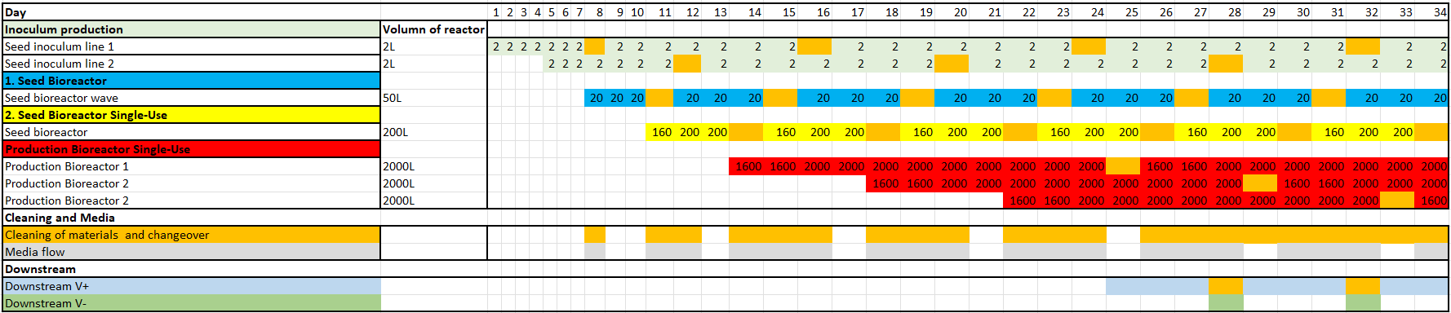

Figure 2: Occupany list of USP, DSP with media and buffer flow.

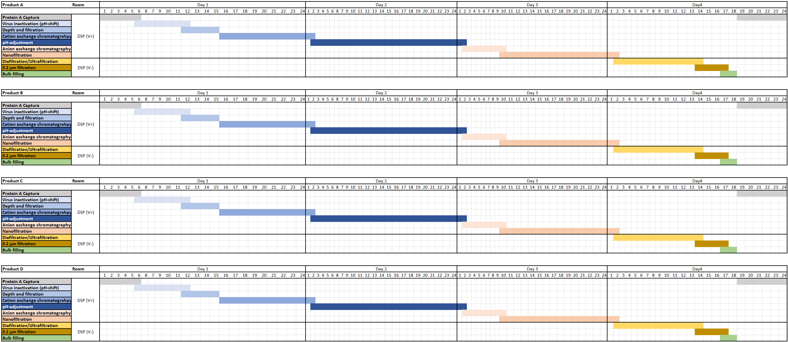

Figure 3: Occupancy list specific for DSP. Every step, which will be conducted is listed, with the estimated time in hours to perform the downstream steps.

## Block flow diagram

The whole product process will be displayed in a block flow diagram. This will show the volumes, concentrations and flows, in a step-by-step illustration. For each product a block flow diagram was made, showing the USP and the DSP of the respective product as well as the used equipment in the respective steps and in or outflow of media and buffer. All of the block flow diagram are going through the same steps already roughly described in the chapter … trough the occupation list. The only difference in each block flow diagram would be the different titer of each product.

The block flow diagram in the figure … is for the product A. Product A has a titer of 4 g/L and an output of …. L.

The first step is the inoculum production with a starting volume of 2 L for the first passage. The inoculum production will be performed in 2L shake flasks. After two days the second passage will be performed with additional two days of cultivation. Afterwards a third passage will be performed with 3 days cultivation, marking it the last step of the inoculum production. The second step will be performed in a 50 L seed bioreactor with 2L of the cell culture from the previous step and start volume of 16 L. In addition, 4L of medium will be added during the three days cultivation. The 20L of cell culture will then be transferred into a 200L STR seed bioreactor for the third step. Cultivation will be performed in this reactor for 3 days, with a starting volume of 160 L. On day two of the cultivation, 40 L of feed medium will be added two the process. Step 4 will take place in a 2000 L STR seed bioreactor, for the production of the mAbs. The working volume in this step will start with 1600 L, which also includes the 200L of inoculum from the previous chapter. Another 400L of feed medium will be added to the process on day 3.

Only one DSP line is needed for the purification of all four products, since the sequential USP approach provides a new batch each 3.7 days and the total DSP time is 3.8 days. By temporally separating the processes, any contamination between products is avoided. For the first chromatography step (protein A capture) the material is introduced into a ÄKTA™ ready XL system, which is flushed and washed by different buffers provided directly from the buffer storage suites over an aseptic connection to a buffer management system. The eluted and purified product is collected in two 2000 L tank. The material is then aseptically connected to an Allegro™ MVP system for virus inactivation, which is also tied to the buffer management system. The same Allegro™ MVP system is used to pump the virus inactivated product through three connected depth filters. The filtrate is collected in a 2000L and 2500L tank, which are subsequentially transported with a drive unit to a second ÄKTA™ ready XL system for cation exchange chromatography (CIEX). The purified product is eluted into a 2000 L tank and transported to a second Allegro™ MVP system for pH adjustment. This step is performed directly in the stirrable 2000 L tank and with buffers provided from the buffer suites in totes. This tank is then brought to a third ÄKTA™ ready XL system for anion exchange chromatography (AIEX). The eluted and purified product is collected in a 2000L tank. Both, CIEX and AIEX ÄKTA systems are managed by one buffer management system. The nanofiltration step is performed on the same Allegro™ MVP system as the pH adjustment step, to which two nanofiltration capsules must be installed. The virus filtered product is collected in a 2000L tank, which is ready to be transported to the ‘DSP V-‘ room.

Once the product arrives in the viral free zone, it is further processed in a fully automated centrasette TFF system, which is also supplied with buffer by a buffer management system linked to the adjacent buffer storage suites. The ultra- and diafiltrated material is directly connected to one depth filter and then collected in a 500 L tote. The purified bulk material is filled and transported by trolley to the DSP freezing room and finally to the storage room.

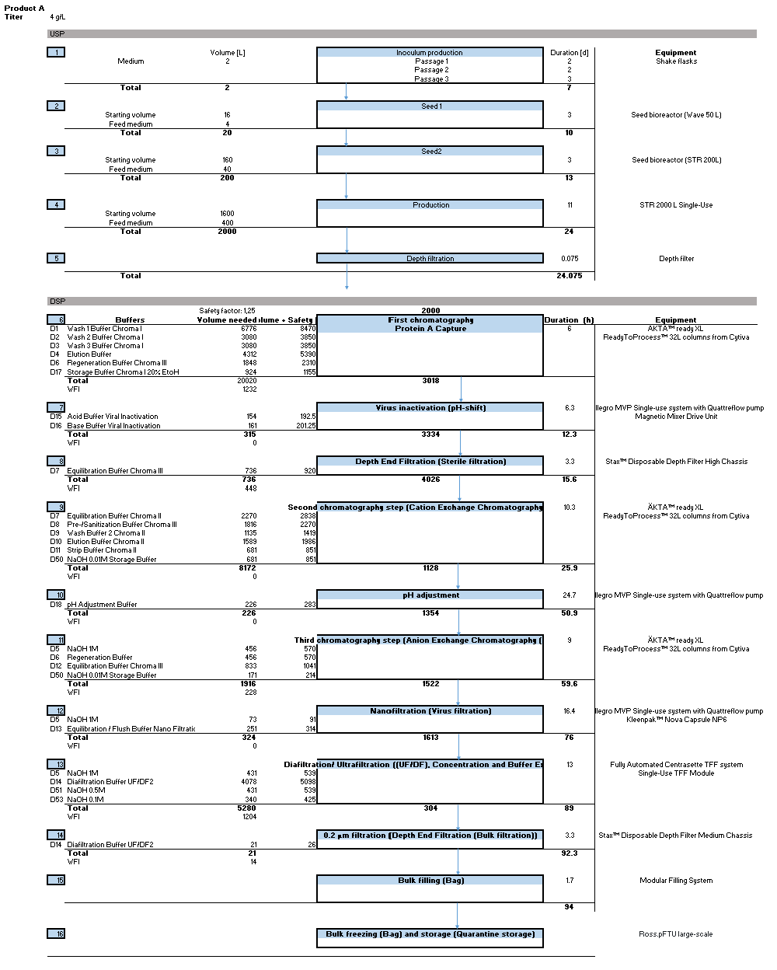

Figure 4: Block flow diagram of product A.

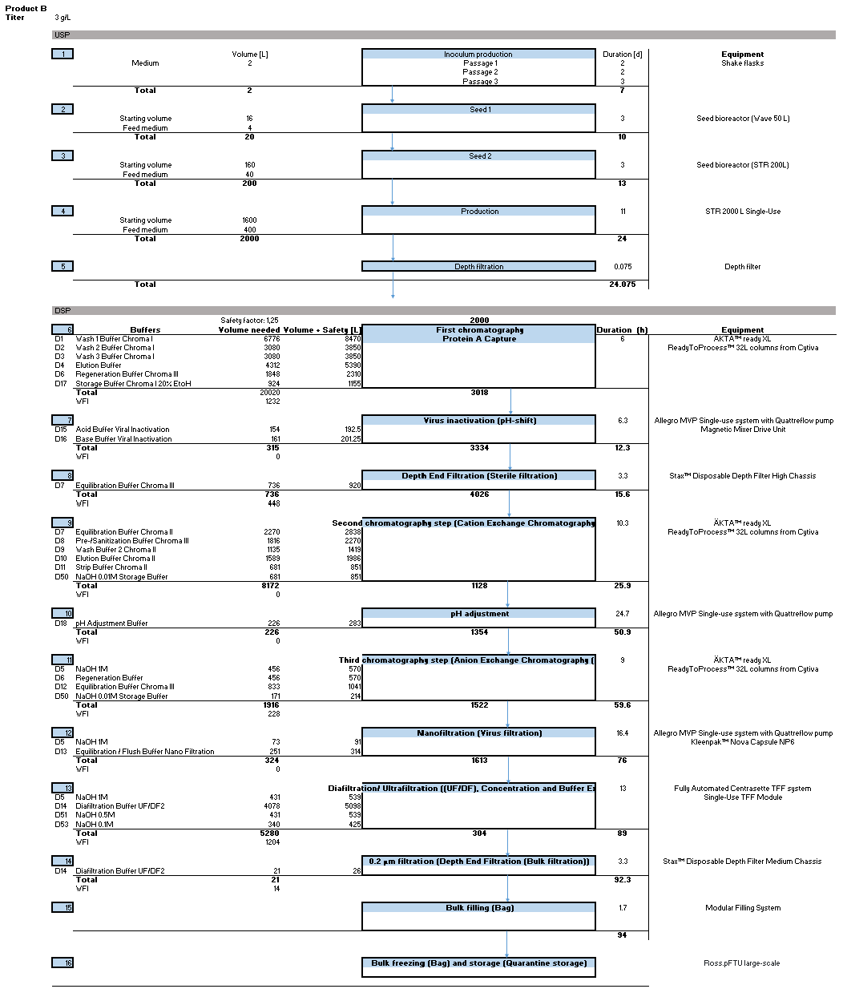

Figure 5: Block flow diagram of product B.

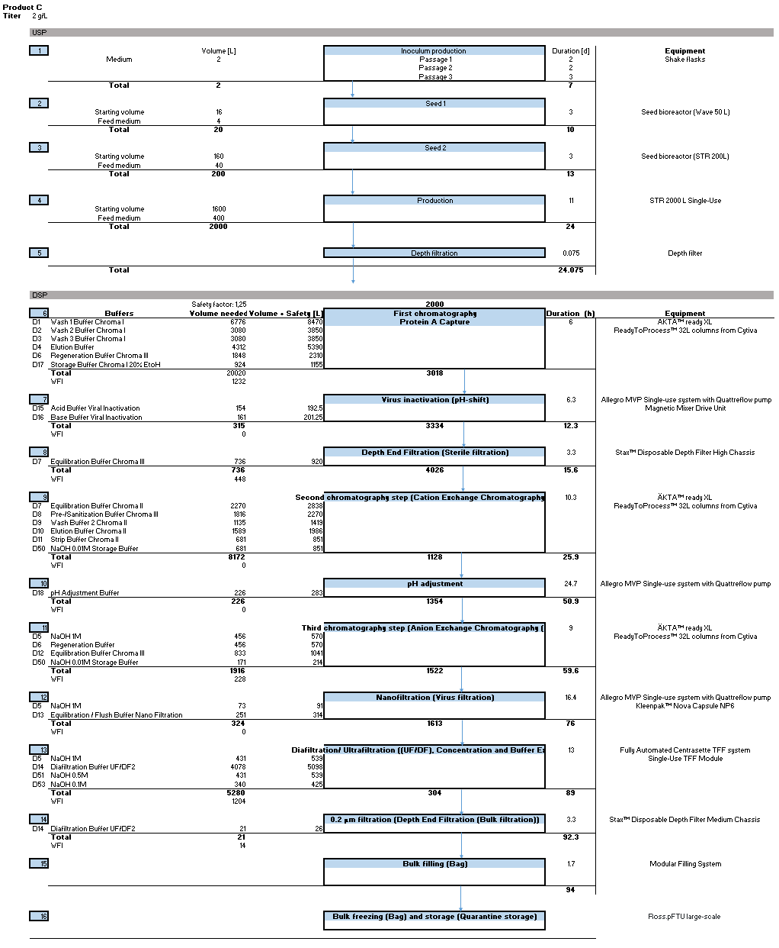

Figure 6: Block flow diagram of product C.

Ein Bild, das Tisch enthält.

Figure 7: Block flow diagram of product D.

## Area schedule and room list

A HakoBio drawing of the Production facility was used to estimate the area of every room as well as the overall footprint of the building, which has been estimated as circa XXX square meters. The table XXX shows detailed list of every room, sorted by which floor they are on, and process step they are a part of. Moreover, the Biosafety level, the Hygiene class and the function of the relevant rooms are reported in this list.



### Biosafety leves

### Area classification

### Zone Concept

The figures X-Z present a schematic view of the zone concept for the production site. In these schemes, the dimensions are not representative to the real production facility. The zone concept was designed in a way to avoid cross-contamination when moving the product to and from the different production steps. The different colours of the rooms correspond to their hygiene zones, with D-class in yellow, C-class in green, Controlled-not-Classified (CNC) in grey and non-classified (NC) in white. The grey-yellow boxes represent the airlocks, which are necessary for material and personnel to change rooms with different hygiene classes safely. The personnel movements are depicted with blue arrows, the product with red arrows, the waste in green and finally the material flow is represented by purple arrows.

The following figure X depicts zone concept of the actual biopharmaceutical production facilities located on the ground floor. It is shown that only DSP and the inoculum lab are specified as class C. The administration is the only room which is CNC. Finally, the quality control, the Media/Buffer preparation and storage, as well as the USP production and harvest operate under class D requirements.

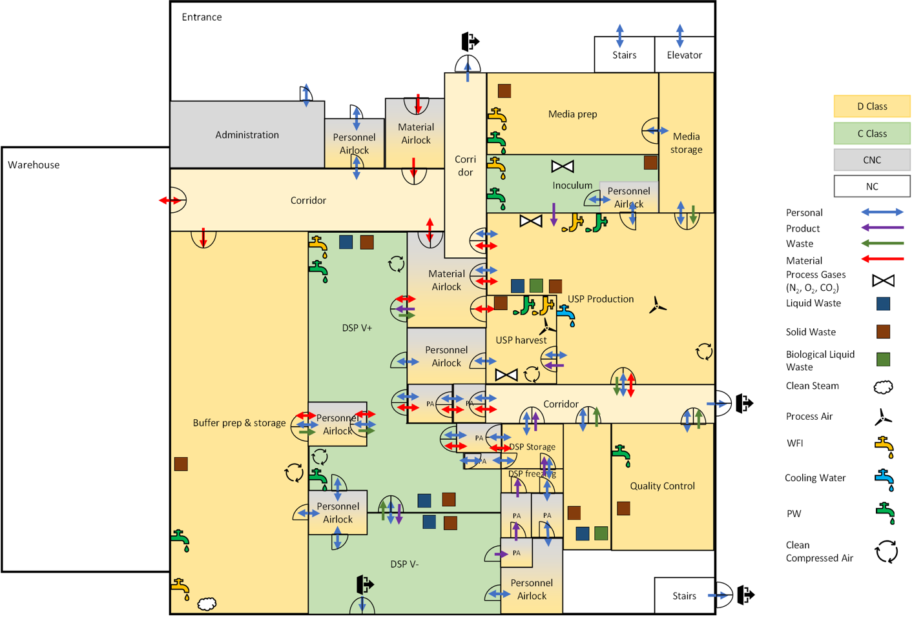

Employees who enter the building may reach the specified area through a personnel airlock. In case of material that is required for production can either be brought into the zone D by passing the material airlock or directly from the warehouse. To reach the more strictly classified zone C both material and personnel must cross another airlock.

In the figure Y the zone concept of the 1st floor is visible. As there are no critical processes performed here, it makes no sense to apply a classified zone on this floor. Furthermore, the operation under classified areas causes higher costs and the additional clothing maybe uncomfortable for the employees. Therefore, the enter floor is a non-classified area.

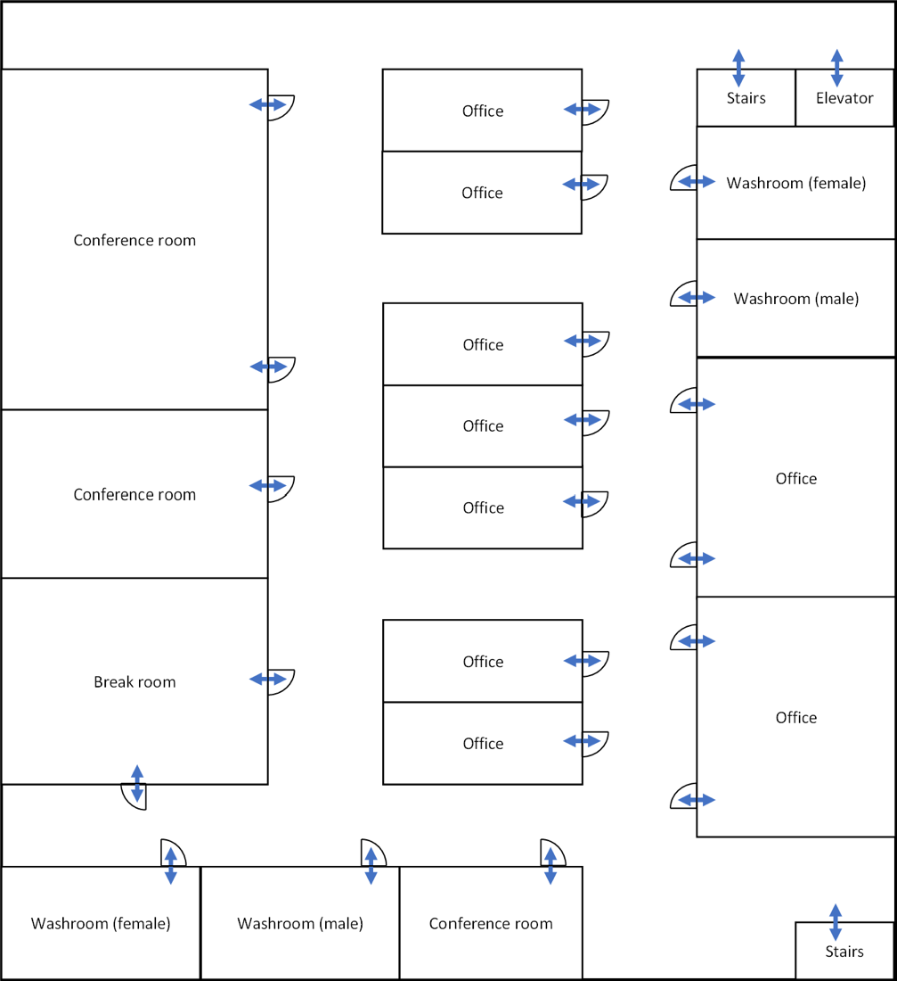

Figure 8: Zone concept of the 1st floor. Many office and conference rooms are located on this floor.

The zone concept of the 2nd floor is shown in the figure Z. On this level the HVAC system is installed. Due to the fact that no product critical process steps are executed here either, the entire floor is a NC area.

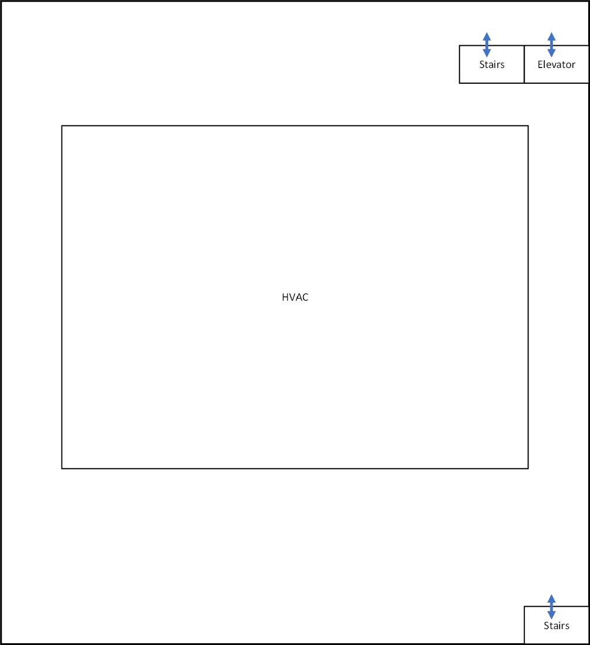

## Height Concept

The hight concept defines how many floors the production facility needs and the height of every specific floor. As it is seen in the figure …, the production facility consists of 4 flours, a warehouse attached to the building and an entrance at the production floor(ground floor). The height of the floors was defined according to the necessary equipment that will be used in them. The different heights are listed in the table … .

Production of the different mAb products and their respective quality control will take place on the ground floor. The overall height of the production floor will be 3 meters with exception to the media- and buffer-preparation/storage room for the reason, that these sections have the highest containers in the production area. Additional crawl space for maintenance of the air ventilation system is implemented. The basement houses different utilities that a production facility needs to be fully functional and technical areas for data storage or power generators. Several areas were allocated for WFI-production, which will be used in trough out the mAb production processes, as well as several containers for containment and waste neutralisation. Also, power and emergency generators to provide electricity to the whole facility, even in cases such as power outages. The first floor consists of offices for the employees and conference rooms. A height of 5 meters was determined for this floor to leave enough space for interior design ideas to build a pleasing atmosphere for the future employees. The second floor builds an additional area for technical utilities but is more specifically planed for air handling units (AHUs) and other HVAC utilities. Some of these devices are connected to production rooms through ventilation systems, to provide clean air. As already mentioned, the warehouse is attached on the sides of the building and will be used to store materials. Storage of the materials in shelves makes the work deployment of certain equipment more efficient and eases the overview of the inventory. A height of 7 meters will provide enough volume for the storage of all the single-use and reusable goods, as well as raw materials. Also attached to the main body of the building is the entrance. The entrance should also include a cafeteria and cantina for lunch breaks and after noon breaks, as well as giving the employees the possibility to have a breakfast. Keeping it near the production area will increase the use of time for the employees, due to the little distance of the break room.

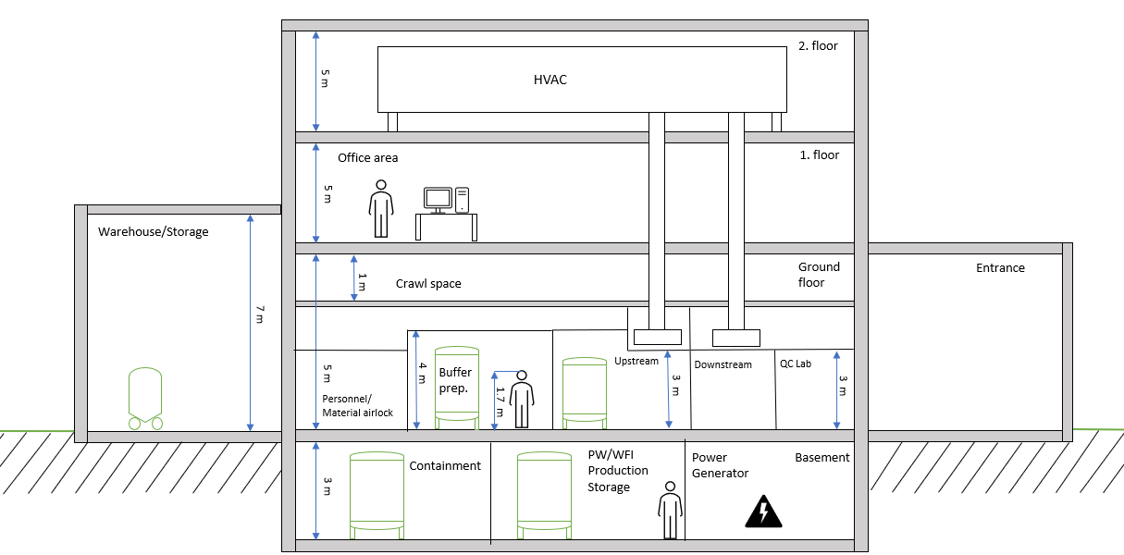

Figure 9: Height concept of the designed production facility for mAb production. The different floors, with their respective heights can be seen, as well as the heights of the attached buildings, e.g.warehouse.

Table **4**: Summary of the different rooms and their corresponding height in meters

|  |  |
| --- | --- |
| **Room** | **Height [m]** |
| Basement | 3 |
| Personnel/Material airlock | 3 |
| Buffer Preparation | 4 |
| Upstream | 3 |
| Downstream | 3 |
| Warehouse Storage | 7 |
| Crawl space | 1 |
| Entrance | 5 |
| Office | 5 |
| HVAC room | 5 |

## Staff requirement

The total number of Full Time Equivalents (FTE) in shift mode for each department of the production facility was calculated based on the required working days per week, the number of shifts and the number of FTE per shift following the equation 1 below. The results are depicted in the table 5.

Equation 1: Formula to calculate the required staff, dependent on the work days, amount of shifts and employees in an area.

$$FTE=\frac{\left(\left(5⋅\frac{days}{week}\right) ⋅ numbersofshift ⋅\frac{FTE}{shift}\right)}{21}$$

In addition, the amount of FTE per area was determined by summing the FTE in shift mode, the FTE day team and the FTE manager. Thus, the number of employees that must be hired corresponds to a total of 84.6 FTE. Furthermore, the maximum of Full Time Equivalents, which are simultaneously at the facility is 51.

Table 5: FTE estimation in different areas of occupations, in the designed facility.

|  |  |  |  |  |  |  |  |
| --- | --- | --- | --- | --- | --- | --- | --- |
| **Area** | **Working days** | **Shifts** | **FTE per Shift** | **Total FTE (Shift)** | **FTE Day Team** | **FTE Manager** | **Total FTE** |
| USP | 7 | 2 | 3 | 10.0 | 1.0 | 0.5 | 11.5 |
| DSP | 7 | 3 | 3 | 15.0 | 1.0 | 0.5 | 16.5 |
| Buffer preparation | 5 | 1 | 2 | 2.4 | 0.5 | 0.5 | 3.4 |
| Media preparation | 5 | 1 | 2 | 2.4 | 0.5 | 0.5 | 3.4 |
| Clean utilities | 7 | 1 | 2.5 | 4.2 | 0.0 | 0.25 | 4.4 |
| Black utilities | 7 | 1 | 1.5 | 2.5 | 0.0 | 0.25 | 2.8 |
| Warehouse/logistics | 5 | 2 | 2 | 4.8 | 0.0 | 0.25 | 5.0 |
| Building Management | 5 | 1 | 2 | 2.4 | 1.0 | 0.25 | 3.6 |
| QA | 5 | 1 | 0 | 0.0 | 4.0 | 1.0 | 5.0 |
| QC | 7 | 3 | 2 | 10.0 | 0.0 | 1.0 | 11.0 |
| Process Development | 5 | 1 | 0 | 0.0 | 6.0 | 1.0 | 7.0 |
| Administration | 5 | 1 | 0 | 0.0 | 10.0 | 1.0 | 11.0 |
|  |  |  |  | Total FTE |  |  | 84.6 |
|  |  |  |  | Max. FTE simultaneously in Facility | | | 51 |

# Upstream Process

## Introduction

Engineered mammalian cells are used for the production of monoclonal antibody (mAb). The preliminary steps in their generation are comprised in Upstream Processing (USP). USP includes cell culture seed development, inoculum, bioreactor culturing and harvest (Joseph, 2018). The crucial aim of USP is to scale up the volume of culture systems up to several thousand liters, in order to produce kilograms of the desired mAb in a facility designed to reduce the risk of contamination.

The workflow for this case study is represented in Figure () and it can be summarized as follows.

The seed train is characterized by three passages performed in 7 days to obtain a final volume of 2 L in shake flask. Then the content of the 2 L shake flask is transferred into the 50 L wave bag bioreactor together with 14 L of basal medium and 4 L of feed medium to reach a final volume of 20 L. After 3 days cells are transferred into the seed STR 200 bioreactor with 140 L of basal medium, on the second day of cultivation in this bioreactor 40 L of feed medium are added. Cells are recollected 3 days after start. At this point cells are introduced in STR 2000 bioreactor, and 1400 L of basal medium are added. Feeding is started 3 days after the beginning of production with 400 L of medium to achieve a final volume of 2000 L. According to our calculations (refer to chapter 3.2) three STR 2000 bioreactors are necessary to produce 72 batches per year. Once completed the production phase, cells are harvested by a filtration step with depth filter before sending the product to the downstream processing (Eibl, 2022).

## Calculations

To determine the number of batches that will be needed to achieve the required production, the following formula has been used:

Equation 2: Total amount of batches per year needed, of all the four mAb products (A to D), to fulfill the URS of the production facility.

$$Total required batches per year \left[\frac{batch}{year}\right]=\sum{\frac{Required amount per year \left[\frac{kg}{year}\right]}{Amount of product per batch \left[\frac{kg}{batch}\right]}}=$$

$$\frac{100 \left[\frac{kg}{year}\right]}{5.472 \left[\frac{kg}{batch}\right]}+\frac{70 \left[\frac{kg}{year}\right]}{4.236 \left[\frac{kg}{batch}\right]}+\frac{70 \left[\frac{kg}{year}\right]}{2.56 \left[\frac{kg}{batch}\right]}+\frac{40 \left[\frac{kg}{year}\right]}{4.12\left[\frac{kg}{batch}\right]}=19+17+28+8=72 \left[\frac{batch}{year}\right]$$

Knowing the number of batches needed, the number of batches that can be done (in one year) using one bioreactor has been calculated as follows:

Equation 3: Calculation for number of batches needed to produce the defined amount of mAb product A according to the USR, for a year.

$$Number of batches \left[-\right]=\frac{operational readiness \left[d\right] }{length of production in bioreactor\left[d\right]}=\frac{320 d -13 d}{(11+1) d}=25.58 ≈25$$

Where the operational readiness and the production time in the bioreactor is given by the Operational requirements in the URS document. One day has been added to the production time for cleaning purposes

It is then possible to calculate the number of bioreactor lines that will be necessary to reach the yearly production rate with the following formula:

Equation 4: Calculation for the number of required production bioreactors.

$$Number of bioreactor lines\left[-\right]=\frac{Total required batches per year \left[\frac{batch}{year}\right]}{batches per year per reactor \left[batch\right]}=\frac{72}{25 }=2.88 ≈3$$

With the number of bioreactor lines, the minimum number of seed trains can be calculated as follows:

Equation 5: Calculation for the number of required seed lines.

$$Number of seed lines\left[-\right]=\frac{number of bioreactor lines\left[-\right]*length of a seeding process \left[d\right]}{length of production in bioreactor\left[d\right]}=\frac{3 *(3+1) d}{(11+1) d}=1$$

In this calculation, an additional day has been added to each step to account for the cleaning and preparations of the utilities. Only one seed line will be necessary to meet the production requirements.

Finally, the number of inoculum lines can be determined with the following formula:

Equation 6: Calculation for the number of required inoculum lines.

$$Number of inoculum lines\left[-\right]=\frac{number of bioreactor lines\left[-\right]*length of an inoculum process \left[d\right]}{length of production in bioreactor\left[d\right]}=\frac{3 *(7+1) d}{(11+1) d}=2$$

An additional day has also been used in each step to account for the cleaning and preparation of the utilities. In this case, two inoculum lines will be required.

These results are the basis on which the rest of the production plan will be designed.

## Plant on a page

For the upstream process, a plant on a page was designed (refer to Figure 9). The main goal is to get an overview over the whole process. Also, the necessary equipment can be listed that way. The plant on a page consists of four steps: the inoculum step, seed 1, seed 2, the production step and a depth filtration step. The detailed description for each step can be found in chapter 3.1. As mentioned, three production lines are planned to be used therefore three STR 2000 bioreactors were added. Only the lines of one production reactor were drawn to avoid clutter. The media and feed container are shown, however those are to be transferred from the media preparation room.

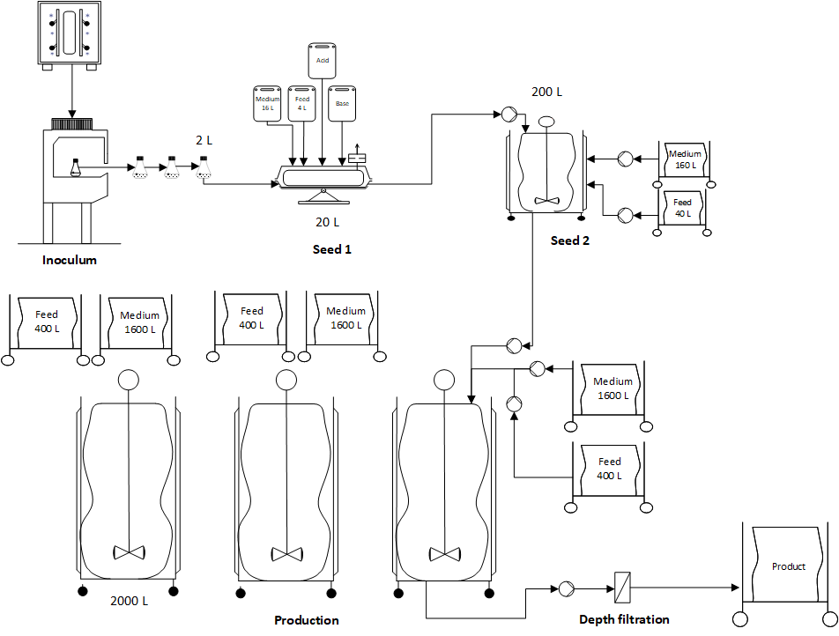

Figure 10: USP Plant on a page

## HakoBio room concept

For the simulation and visualization of the room concept, the HakoBio software from PALL Corporation was used. The images are shown as 3D visualization and represent the inoculum room (1), seeding (2) and production (3) room, followed by the transfer (4) to the harvest room and depth filtration process(5). Finally, the production is transferred further to the DSP (6) Lastly transferring the production further to the DSP (6) (Figure 10). The devices and production equipment used for this design are described and shown in chapter 3.5. The production process starts in the inculation room, in cleanliness class C. Followed by a material and personnel airlock, the seeding and USP process are in the same room. This room is categorized as cleanliness class D. Hereby the process is divided into the seeding train and production process. Last of all, the harvesting is performed in a separate room, also classified as class D.

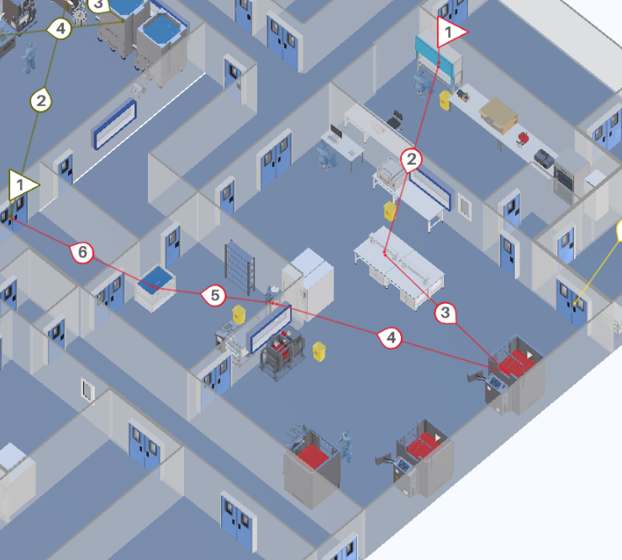

Figure 11: 3D layout of the USP process (created with HakoBio), The process flow is shown with the red process line, starting in the inoculum room (1), seeding (2) and production (3) room, followed by the transfer (4) to the harvest room (5), where the depth filtration is performed. Lastly transferring the production further to the DSP (6).

## Size and functions of USP system

In this paragraph Table shows the equipments required for USP in mAb production. The table highlights the types of material, their quantity, power consumption and size. The analysis of the equipments needed and their size is crucial for the biopharmaceutical facility design.

Table 6:

|  |  |  |  |  |
| --- | --- | --- | --- | --- |
| **INOCULUM LAB** | | | | |
| **Equipment** | **Size (WxDxH) [m]** | **Power consumption [W]** | **Quantitiy** | **Photo** |
| Laminar Flow Hood | 1.78 x 0.59 x 2.20 | 69 | 1 |  |
| Nucleo- Counter® NC-200™ | 0.46 x 0.26 x 0.26 | 20 | 1 |  |
| Combined refrigerator-  freezer | 0.6 x 0.7 x 2.01 | 2900 | 1 |  |
| Large-Capacity Reach-In CO2 Incubator | 0.96 x 0.92 x 2.03 |  | 1 |  |
| SWBR17 SHEL LAB Shaking Water bath | 0.65 x 0.41 x 0.4 | 900 | 1 |  |
| Large Benchtop | 2.83 x 0.80 x 0.80 | - | 1 |  |
| Large Laboratory Bench | 2.49 x 0.98 x 0.80 | - | 2 |  |
| Chair | 0.66 x 0.66 x 0.86 | - | 1 |  |
| Desktop Computer | 0.57 x 0.32 x 0.50 | 200 | 1 |  |
| Biohazard trash | 0.4 x 0.67 x 0.33 | - | 1 |  |
| Inverted microscope | 0.34 x 0.51 x 0.61 | 3 | 1 |  |
| Stool | 0.4 x 0.35 x 0.59 | - | 1 |  |
| Cell culture media | 0.12 x 0.12 x 0.28 | - | 1 |  |
| INFORS Multitron II Stackable incubation shaker | 1.1 x 0.88 x 0.55 | 330 | 1 |  |

|  |  |  |  |  |
| --- | --- | --- | --- | --- |
| **USP – SEEDING** | | | | |
| **Equipment** | **Size (WxDxH) [m]** | **Power consumption [W]** | **Quantitiy** | **Photo** |
| Allegro™ STR 200 L Single- Use Jacketed Stirred Tank Bioreactor | 1.62 x 1.17 x 2.12 | - | 1 |  |
| Allegro™ XRS 25 Bioreactor System | 0.90 x 0.60 x 0.62 | - | 1 |  |
| Double Benchtop | 1.52 x 1.55 x 1.18 | - | 2 |  |
| Biohazard trash | 0.4 x 0.67 x 0.33 | - | 1 |  |

|  |  |  |  |  |
| --- | --- | --- | --- | --- |
| **USP - PRODUCTION** | | | | |
| **Equipment** | **Size (WxDxH) [m]** | **Power consumption [W]** | **Quantitiy** | **Photo** |
| Allegro™ STR 2000 L Single- Use Stirred Tank Bioreactor | 1.78 x 1.74 x 2.93 | - | 3 |  |
| Desktop Computer | 0.57 x 0.32 x 0.50 | 200 | 1 |  |
| Corded telephone | 0.24 x 0.3 x 0.04 | 2 | 1 |  |
| Biohazard trash | 0.4 x 0.67 x 0.33 | - | 2 |  |
| Small laboratory bench | 1.51 x 0.69 x 0.81 | - | 1 |  |
| Chair | 0.66 x 0.66 x 0.86 | - | 1 |  |

|  |  |  |  |  |
| --- | --- | --- | --- | --- |
| **DEPTH FILTRATION** | | | | |
| **Equipment** | **Size (WxDxH) [m]** | **Power consumption [W]** | **Quantitiy** | **Photo** |
| Stax™ Disposable Depth Filter System | 0.80 x 1.15 x 1.94 | - | 1 |  |
| Allegro MVP Single-use system with Watson Marlow pump | 0.96 x 1.28 x 1.13 | - | 1 |  |
| Allegro™ 3D 2000 L Modular Tote | 1.26 x 1.07 x 3.01 | - | 1 |  |
| Biohazard trash | 0.4 x 0.67 x 0.33 | - | 1 |  |
| Stock Shelves | 1.40 x 0.30 x 2.00 | - | 1 |  |

# Downstream Process

## Introduction

The downstream process (DSP) is the second important step of the core manufacturing process and it aims to render the product to its final bulk formation. For this purpose, the clarified product is isolated, concentrated and polished in several steps and then packed in closed and transportable containers for fill-finish activities (John Joseph- Chapter 45).

For this case study work it was decided to physically segregate the main downstream activities in two separate suites, one for all activities prior to the virus filtration (nanofiltration) and one for all following activities, such as diafiltration, ultrafiltration and bulk filling. To highlight the separation, the rooms were labelled as 'DSP V+' and 'DSP V-', both corresponding to cleanroom class C. The rational for this design is to avoid any cross-contamination of the post-viral process material with potentially contaminated pre-viral material. The filled product is then fed through a material lock into a CNC room for bulk freezing before being stored in an adjacent storage room. Further process support activities, such as washing clean and staging, are to take place in a separate class D cleaning room adjacent to the 'DSP V+' room. The DSP is constantly monitored by three full-time staff members, two of whom work primarily in the pre-viral and one in the post-viral filtration zone. The following subchapters provide more in-depth information on the process, the premises and the equipment used in DSP.

## Plant on a page

In picture XY you can see the DSP plant on a page. The product will be transported in a mobile tote to the DSP V+ room.

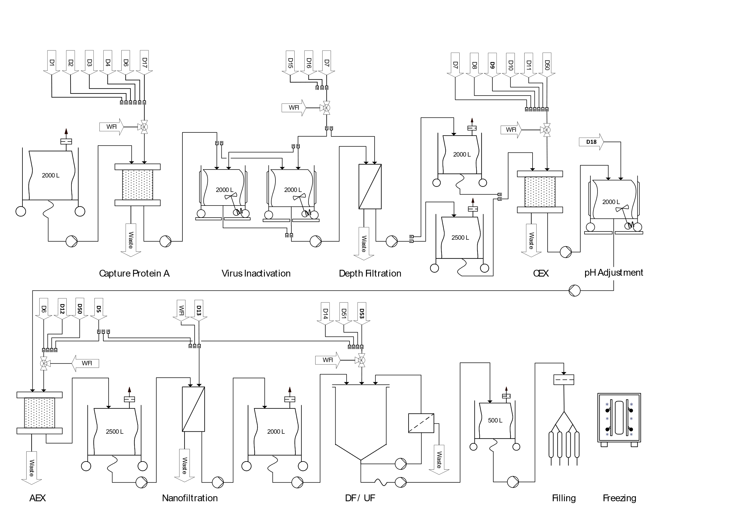

Figure 12 DSP Plant on a Page.

## Hako Bio room concept

One DSP line is planned for the purification of all four products, since the sequential USP approach provides a new batch each 3.7 days and the total DSP time is 3.8 days. Therefore, DSP can start processing a new batch as soon as the previous batch is in the filling and finishing phase. By temporally separating the processes, any contamination between products is avoided.

The product from the upstream processing is transported to the ‘DSP V+’ suite via an material airlock. For the first chromatography step (protein A capture) the material is introduced into a ÄKTA™ ready XL system, which is flushed and washed by different buffers provided directly from the buffer storage suites over an aseptic connection to a buffer management system. The eluted and purified product is collected in two 2000 L tank. The material is then aseptically connected to an Allegro™ MVP system for virus inactivation, which is also tied to the buffer management system. The same Allegro™ MVP system is used to pump the virus inactivated product through three interconnected depth filters (21 Stax filters with 1m2 area – amount approximated with a filterability of 3). The filtrate is collected in a 2000L and 2500L tank, which are subsequentially transported with a drive unit to a second ÄKTA™ ready XL system for cation exchange chromatography (CIEX). The purified product is eluted into a 2000 L tank and transported to a second Allegro™ MVP system for pH adjustment. This step is performed directly in the stirrable 2000 L tank and with buffers provided from the buffer suites in totes. This tank is then brought to a third ÄKTA™ ready XL system for anion exchange chromatography (AIEX). The eluted and purified product is collected in a 2000L tank. Both, CIEX and AIEX ÄKTA systems are managed by one buffer management system. The nanofiltration step is then performed on the same Allegro™ MVP system as the pH adjustment step, to which two nanofiltration capsules must be installed. The virus filtered product is collected in a 2000L tank, which is ready to be transported to the ‘DSP V-‘ room.

Once the product arrives in the viral free zone, it is further processed in a fully automated centrasette TFF system, which is also supplied with buffers by a buffer management system. The ultra- and diafiltrated material is directly connected to one depth filter (4 Stax filters with 0.5 m2 area – amount approximated with a filterability of 3) and then collected in a 500 L tote. The purified bulk material is filled and transported with a trolley to the DSP freezing room and subsequent storage room.

HAKOBIO FIGURE

## Size and functions of DSP system

The required equipment for the DSP rooms, their size and quantity are provided in tables X, X X, and X. The DSP relies heavily on single-use peripheral elements, such as connectors, aseptic transfer systems, tank liners and valves. Among the single-use equipment worth mentioning is the Allegro™ Connect Buffer Management System. Concentrated buffer solutions from the buffer cold storage room are coupled via an aseptic connection across the wall to the buffer management system in the DSP suites, where they are mixed with WFI and directly available to supply the equipment’s. Furthermore, three ÄKTA™ ready XL systems are located in the 'DSP V+’ rooms, each dedicated to one chromatography step. This setup allows more flexibility, especially in cases where upstream or downstream process times could be shortened and several ÄKTA™ ready XL systems could be operated in parallel. Finally, it is worth mentioning the Allegro™ MVP disposable system. This device is an excellent all-rounder for several DSP steps such as virus inactivation, pH adjustment, depth filtration and nanofiltration. Overall, the single-use approach generates higher operating costs and stronger dependence on suppliers. However, the increased flexibility and reduced facility footprint (no CIP/SIP, column packing room necessary) are especially advantageous for DSP. Furthermore, single-use systems are safer due to the decreased risk of microbial contamination, which is of absolute priority in a multiproduct facility.

Table 7: Required equipment for the DSP V+ area.

|  |  |  |  |  |
| --- | --- | --- | --- | --- |
| **DSP V+** | | | | |
| **Equipment** | **Information** | **Quantity** | **Size (WxDxH)**  **[m]** | **Photo** |
| Allegro™ Connect Buffer Management System | In-line buffer dilution system  Energy consumption: 230V | 2 | 1.12x1.12x1.99 | Allegro™ Connect Buffer Management System |
| [2000 L Jacketed Cubical Tank with Load Cell](https://pall.hakobio.com/Portfolio/7fde819d-4c6e-4f9f-aa31-90174e6097fd) | Stainless Steel Tank for Use with Magnetic Mixer Drive Unit | 6 | 1.78x1.39x2.65 | 2000 L Jacketed Cubical Tank with Load Cell |
| 2500 L Jacketed Cubical Tank with Load Cell | Stainless Steel Tank for Use with Magnetic Mixer Drive Unit | 1 | 1.75x1.66x2.29 | 2500 L Jacketed Circular Tank with Load Cell |
| ÄKTA™ ready XL - | Single-use chromatography system.  Flow rates from 45 to 3500 L/h | 3 | 1.28x1.15x1.95 | ÄKTA™ ready XL single-use system from Cytiva |
| [ReadyToProcess™ 32L columns from Cytiva](https://pall.hakobio2.com/Portfolio/c424a252-e5e4-4856-be4c-4c1617a5e52e) | Chromatography columns for protein A capture | 1 | 0.7x0.7x0.63 |  |
| [ReadyToProcess™ 32L columns from Cytiva](https://pall.hakobio2.com/Portfolio/c424a252-e5e4-4856-be4c-4c1617a5e52e) | Chromatography columns for CIEX | 1 | 0.7x0.7x0.63 |  |
| [ReadyToProcess™ 32L columns from Cytiva](https://pall.hakobio2.com/Portfolio/c424a252-e5e4-4856-be4c-4c1617a5e52e) | Chromatography columns for AIEX | 1 | 0.7x0.7x0.63 |  |
| Allegro™ MVP Single-use system with Quattreflow pump | Multipurpose applications  Energy consumption :230V | 2 | 0.96x1.28x1.13 |  |
| [Magnetic Mixer Drive Unit](https://pall.hakobio2.com/Portfolio/b48ebc94-36b1-4e9b-b1dd-0f6fa3c8309d) | Robust single-use mixing system | 3 | 0.4x0.82x1.03 |  |
| Stax™ Disposable Depth Filter High Chassis- | Chassis for up to 10 Large Stax Disposable Depth Filters - 21 Depth filters used per batch in total | 3 | 0.8x1.15x1.93 | Ein Bild, das drinnen enthält.  Automatisch generierte Beschreibung |
| Kleenpak™ Nova Capsule NP6 | For 100L to 1000L  Virus removal filters used with MVP Single-use system | 2 | 0.24x0.24x0.35 | Ein Bild, das Topf enthält.  Automatisch generierte Beschreibung |

Table 8 Required equipment for the DSP V- area.

|  |  |  |  |  |
| --- | --- | --- | --- | --- |
| **DSP V-** | | | | |
| **Equipment** | **Information** | **Quantity** | **Size (WxDxH) [m]** | **Photo** |
| Allegro™ Connect Buffer Management System | In-line buffer dilution system  Energy consumption: 230V | 1 | 1.12 x 1.12 x 1.99 | Allegro™ Connect Buffer Management System |
| Fully Automated Centrasette TFF system | Tangential Flow Filtration System | 1 | 0.8x1.5x1.5 |  |
| [Single-Use TFF Module](https://pall.hakobio2.com/Portfolio/60b5bac3-6af5-42bb-9b08-921ce0f03b38) | Single-Use Module for Concentration/  Diafiltration | 1 | 0.23x0.25x0.09 | Single-Use TFF Module |
| [Stax™ Disposable Depth Filter Medium Chassis](https://pall.hakobio2.com/Portfolio/a382cc57-fefc-4d29-a72a-1f2f5284603c) | Medium chassis for up to 5 Stax Disposable Depth Filters - 4 Depth filters used per batch in total. | 1 | 0.8x1.15x1.31 | Ein Bild, das drinnen enthält.  Automatisch generierte Beschreibung |
| Bulk Filling System |  | 1 | 0.69x1.61x1.58 | Ein Bild, das Gerät enthält.  Automatisch generierte Beschreibung |
| Allegro™ 500L Plastic Tote with Trolley | Collapsible | 1 | 1.22x0.87x1.23 | Allegro™ 500 L Plastic Tote with Trolley |
| Bulk Filling Trolley |  | 1 | 1.02x0.66x1.15 | Bulk Filling Trolley |
| [Magnetic Mixer Drive Unit](https://pall.hakobio2.com/Portfolio/b48ebc94-36b1-4e9b-b1dd-0f6fa3c8309d) | Robust single-use mixing system | 1 | 0.4x0.82x1.03 |  |

Table 9 Required equipment for the DSP Freezing area.

|  |  |  |  |  |
| --- | --- | --- | --- | --- |
| **DSP Freezing** | | | | |
| **Equipment** | **Information** | **Quantity** | **Size (WxDxH) [m]** | **Photo** |
| Ross.pFTU large-scale | Plate-based freeze-thaw unit with control unit | 1 | 3.17x1.39x2.25 | RoSS.pFTU Large-Scale |

Table 10 Required equipment for the DSP Cleaning area

|  |  |  |  |  |
| --- | --- | --- | --- | --- |
| **DSP Freezing** | | | | |
| **Equipment** | **Information** | **Quantity** | **Size (WxDxH) [m]** | **Photo** |
| Sterilization Autoclave GSS-L 6710 EC1 | Steam Sterilizer | 1 | 0.66x1.00x0.70 | Sterilization Autoclave GSS-L 6710 EC1 |

# Media and Buffer preparation

Activities involving media preparation are carried out in separate rooms by operators who are outfitted with appropriate protective equipment. Because of the high particle concentration of this combination of dry media and buffer component, rooms are classified as hygienic zone D and are found on the ground floor. In this study case four products A, B, C, and D with the amount of 19, 17, 28 and 9, respectively were taken into account. The medium preparation consists of 1000 L tank and 2000L tank and is 37 m2. For the buffer preparation room there are it several tanks, in particular 50L, 100L, 500L, 1000L, 1500L, 2000L, 3000L in the area of 192 m2. The buffer cold storage room consists of 124 m2(see Table: Size and Function of Media and Buffer Systems in Appendix).

## Buffer estimation per batch

During this process, 72 batches per year were carried out for the four different products (A, B, C, D) which makes about 2 batches per week. Due to safety reasons and uncomplicated usage, the inline dilution system was used, except for the buffers D5, D13 and D18.

Inline dilution is a process of transferring buffer concentrate, through an aseptic transport system, and diluting it with water directly at the site of use. As a result of using this technique, the efficiency and flexibility are exceeded. It enables to lower facility’s footprint, as well as reduced utilities and equipment costs in the long run. One of the biggest disadvantages is the insurance of the quality of mixed buffer, due to physical difficulties with controlling it. (*Ispe.Org*, 2019)

Beschriftung: Calculations of the required volumes of the different buffers per batch.

|  |  |  |  |  |  |
| --- | --- | --- | --- | --- | --- |
| **Number** | **Buffer** | **Volume per batch [L]** | **Volume per two batch (one week) [L]** | **Volume concentrate per week [L]** | **Storage** |
| D1 | Wash 1 Buffer Chroma I | 6776 | 13552 | 2711 | 3000 |
| D2 | Wash 2 Buffer Chroma I | 3080 | 6160 | 1232 | 1500 |
| D3 | Wash 3 Buffer Chroma I | 3080 | 6160 | 1232 | 1500 |
| D4 | Elution Buffer Chroma I | 4312 | 8624 | 1725 | 2000 |
| D5 | NaOH 1M | 960 | 1920 | - | 2000 |
| D6 | Regeneration Buffer Chroma III | 2304 | 4608 | 922 | 1000 |
| D7 | Equilibration Buffer Chroma III | 3006 | 6012 | 1202 | 1500 |
| D8 | Pre-/ Sanitization Buffer Chroma III | 1816 | 3632 | 726 | 1000 |
| D9 | Wash Buffer 2 Chroma II | 1135 | 2270 | 454 | 500 |
| D10 | Elution Buffer Chroma II | 1589 | 3178 | 636 | 1000 |
| D11 | Strip Buffer Chroma II | 681 | 1362 | 272 | 400 |
| D12 | Equilibration Buffer Chroma III | 833 | 1666 | 333 | 400 |
| D13 | Equilibration / Flush Buffer Nano Filtration | 251 | 502 | - | 400 |
| D14 | Diafiltration Buffer UF/DF2 | 4099 | 8198 | 1640 | 2000 |
| D15 | Acid Buffer Viral Inactivation | 154 | 308 | 62 | 100 |
| D16 | Base Buffer Viral Inactivation | 161 | 322 | 64 | 100 |
| D17 | Chroma I Storage Buffer 20% EtOH | 924 | 1848 | 370 | 400 |
| D18 | pH Adjustment Buffer | 226 | 452 | - | 500 |
| D50 | NaOH 0.01 M Storage Buffer | 852 | 1704 | 341 | 400 |
| D51 | NaOH 0.5 M | 431 | 862 | 172 | 200 |
| D53 | NaOH 0.1 M | 340 | 680 | 136 | 200 |

## Plant on a page

Media and feed preparation has an important role in this process and especially for the upstream process that follows. The following volumes of media and feed are required for the different bioreactors during the process:

Table: Volume data for medium and feed for the entire process

|  |  |  |
| --- | --- | --- |
| Bioreactor | **Media** Volume/batch [L] | **Feed** Volume/batch [L] |
| Seed Bioreactor 1 | 16 | 4 |
| Seed Bioreactor 2 | 160 | 40 |
| Production Bioreactor | 3x 1600 | 3x 400 |

The medium and feed are prepared in stirred tanks and then distributed into transportable bags, where each bioreactor in the upstream process receives the corresponding volume size. The plant on a page is showed on IMAGE ?.

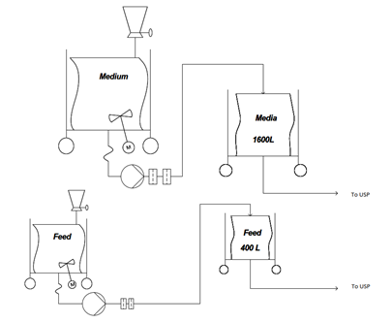

Image: Plant on a page of media and feed preparation for the USP. Image created with Visio®.

Based on the calculations for the buffer preparation, a plant on a page (IMAGE ?) was designed. Each buffer concentrate is produced in a large production reactor and then stored in a tank. The transport of the buffers to the DSP takes place through the inline dilution system. Buffer D5, D13 and D18 are transported through transportable bags and all other buffers through hard pipes.

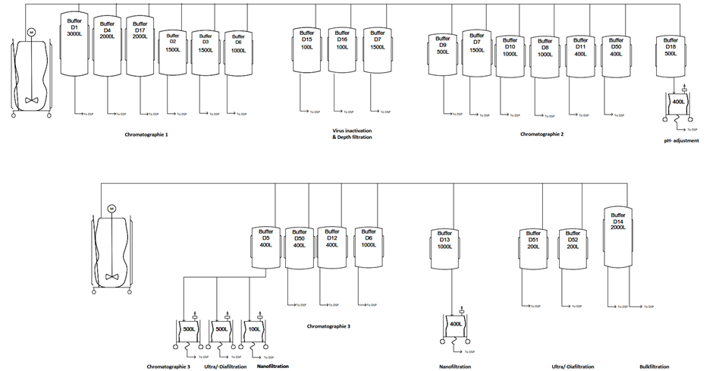

Image: Plant on a page of buffer preparation for the DSP. Image created with Visio®

## HakoBio room concept of media and buffer preparation

**Room concept of Media & feed preparation & storage room**

The room has 37 m2 and is placed close to the USP production, to enable easier and shorter transport of already prepared media and feed to the upstream production. All the used tanks are going to be mobile, and ready for transit of needed materials.

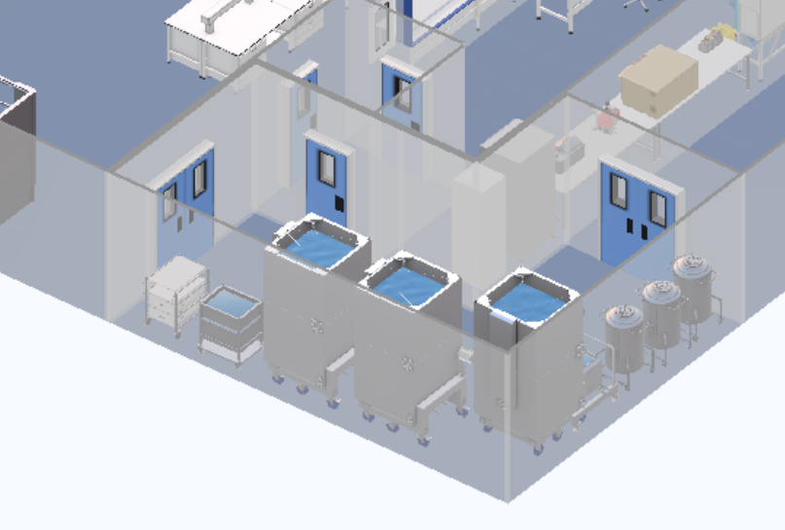

Image: Media & fee preparation & storage room

**Room concept of Buffer preparation & storage**

The buffer preparation has 192 m2 and storage room has 124 m2 and is right next to the DPS production.

The inline dilution system will be used for 18 out of 21 buffers, which made it necessary to place those two rooms close to each other so that the process of transferring buffer into downstream production does not disturb other production steps or the work organization of the whole facility. For the remaining 3 buffers system with preparation in separate tanks and delivery with the use of mobile tanks was chosen, due to difficulties with the placement of the equipment in the DSP production.

Despite the current trend of working with single-use technologies, we have decided to use regular tanks for preparation and storage, due to the very small variation of the used buffers in between the products.

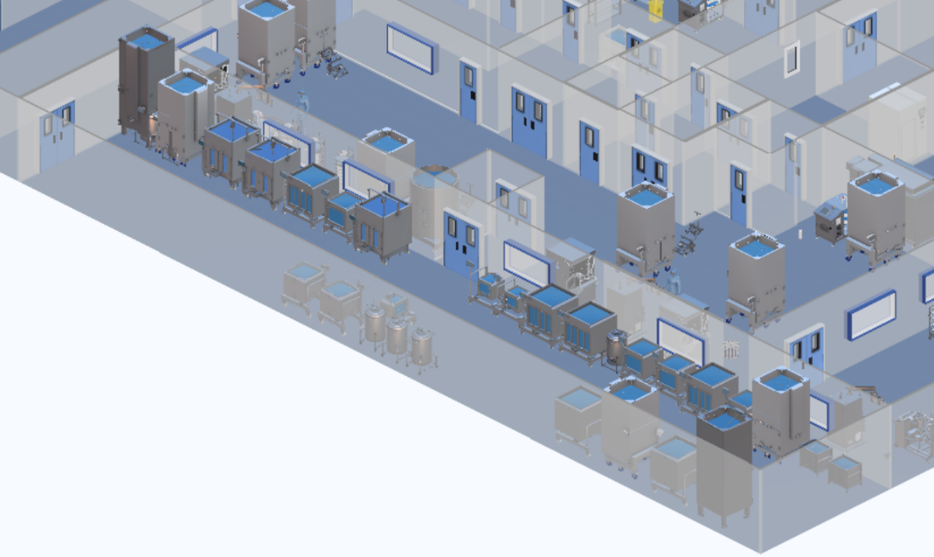

## Image: Buffer preparation & storage room

## Size and function of MP and BP systems

The equipment needed for media and buffer preparation and storage in mAb manufacturing is listed in this paragraph. The table shows the different sorts of materials, as well as their number and size. For the design of a biopharmaceutical facility, a review of the equipment required, and its scale is critical.

Table: Size and Function of Media Systems

|  |  |  |  |
| --- | --- | --- | --- |
| **Media and feed storage and preparation room** | | | |
| **Equipment** | **Quantity** | **Size in m** | **Photo** |
| 2000 L Jacketed Cubical Tank with Load Cell | 3 | 1.78 x 1.39 x 2.65 |  |
| 200 L stainless steel Bioreactor with Trolley | 1 | 0.82 x 0.65 x 1.2 |  |
| 2 x 20 L Biocontainers with Trolley | 1 | 0.71x1.05x0.98 |  |
| 500 L formulation tank | 3 | 0.72 x 0.83 x 1.39 |  |
| 100 L Jacketed Cubical Tank with Load Cell, Stainless Steel | 1 | 1 x 0.86 x 1.58 |  |

Table: Size and Function of Buffer Systems

|  |  |  |  |
| --- | --- | --- | --- |
| **Buffer storage and preparation room** | | | |
| **Equipment** | **Quantity** | **Size in m** | **Photo** |
| 3000 L Jacketed Cubital Tank with Load Cell | 1 | 1.64 x 1.40 x 3.56 |  |
| 2000 L Jacketed Cubical Tank with Load Cell | 2 | 1.78 x 1.39 x 2.65 |  |
| 1500 L Jacketed Cubical Tank with Load Cell | 3 | 1.62 x 1.39 x 2.17 |  |
| 1000 L Jacketed Cubical Tank with Load Cell | 3 | 1.53 x 1.29 x 1.60 |  |
| 500 L Formulation tank | 4 | 0.72 x 0.83 x 1.39 |  |
| 400 L Jacketed Cubical Tank with Load Cell | 5 | 1.27 x 1.01 x 1.58 |  |
| 200 L stainless steel Bioreactor with Trolley | 3 | 0.82 x 0.65 x 1.2 |  |
| 100 L stainless steel Tank | 3 | 1.00 x 0.86 x 1.58 |  |

Sources

*ispe.org*. (2019). <https://ispe.org/pharmaceutical-engineering/may-june-2019/inline-dilution-agile-capability-downstream-manufacturing>

# Quality Control

A rock-solid quality control (QC) is needed to produce four different mAb products. The QC will perform quality analysis of many different parameters, which are essential to the end quality of a product. Analysis will be performed on the raw materials, intermediate products which will be obtained during each step during the process and the end product itself. To fulfil these tasks a laboratory was designed with equipment’s such as a XXX A total of 16 FTEs will be working in this lab, 5 for the QA and 11 for the QC.

## Size and functions of QC systems

Table 11 : Size and Function of Buffer Systems

|  |  |  |  |
| --- | --- | --- | --- |
| **Quality Control Sytems** | | | |
| **Equipment** | **Quantity** | **Size in m** | **Photo** |
| 2000 L Jacketed Cubical Tank with Load Cell | 3 | 1.78 x 1.39 x 2.65 |  |
|  |  |  |  |
|  |  |  |  |

# Clean facility utilities

## List of necessary clean facility utilities

## General facility utilities

## HVAC

## Clean utilities

## WFI and clean steam

## Technical utilities

## Waste

# References

List of Images

**Es konnten keine Einträge für ein Abbildungsverzeichnis gefunden werden.**

List of tables

**Es konnten keine Einträge für ein Abbildungsverzeichnis gefunden werden.**

# Appendix

Table: Calculations of the required volumes of the different buffers per batch.

|  |  |  |  |  |  |
| --- | --- | --- | --- | --- | --- |
| **Number** | **Buffer** | **Product A**  Volume/batch [L] | **Product B**  Volume/batch [L] | **Product C**  Volume/batch [L] | **Product D**  Volume/batch [L] |
| D1 | Wash 1 Buffer Chroma I | 6776 | 6776 | 6776 | 6776 |
| D2 | Wash 2 Buffer Chroma I | 3080 | 3080 | 3080 | 3080 |
| D3 | Wash 3 Buffer Chroma I | 3080 | 3080 | 3080 | 3080 |
| D4 | Elution Buffer Chroma I | 4312 | 4312 | 4312 | 4312 |
| D5 | NaOH 1M | 960 | 960 | 960 | 960 |
| D6 | Regeneration Buffer Chroma III | 2304 | 2304 | 2304 | 2304 |
| D7 | Equilibration Buffer Chroma III | 3006 | 3006 | 3006 | 3006 |
| D8 | Pre-/ Sanitization Buffer ChromaIII | 1816 | 1816 | 1816 | 1816 |
| D9 | Wash Buffer 2 Chroma II | 1135 | 1135 | 1135 | 1135 |
| D10 | Elution Buffer Chroma II | 1589 | 1589 | 1589 | 1589 |
| D11 | Strip Buffer Chroma II | 681 | 681 | 681 | 681 |
| D12 | Equilibration Buffer Chroma III | 833 | 833 | 833 | 833 |
| D13 | Equilibration / Flush Buffer Nano Filtration | 251 | 251 | 251 | 251 |
| D14 | Diafiltration Buffer UF/DF2 | 4099 | 4099 | 4099 | 4099 |
| D15 | Acid Buffer Viral Inactivation | 154 | 154 | 154 | 154 |
| D16 | Base Buffer Viral Inactivation | 161 | 161 | 161 | 161 |
| D17 | Chroma I Storage Buffer 20% EtOH | 924 | 924 | 924 | 924 |
| D18 | pH Adjustment Buffer | 226 | 226 | 226 | 226 |
| D50 | NaOH 0.01 M Storage Buffer | 852 | 852 | 852 | 852 |
| D51 | NaOH 0.5 M | 431 | 431 | 431 | 431 |
| D53 | NaOH 0.1 M | 340 | 340 | 340 | 340 |